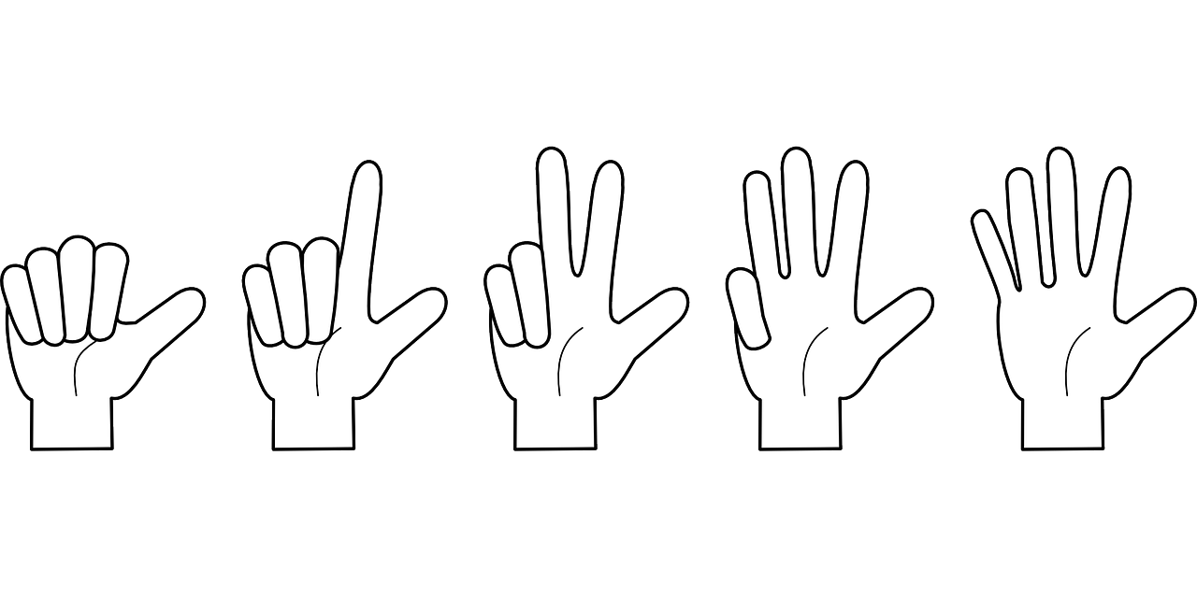

**Counting**

**and**

**The Art of Arithmetic**

**by**

**E.G. Richards**

